Pax8 AutoHotkey Guide

Because there’s too much to cover, and there’s not enough time.

Abstract
The purpose of this guide to assist the Technical Support team – predominantly the Security Endpoint department – to quickly and consistently update the requestors of tickets on the status of their issues.

Why do this?
Because if it means I get to be lazy in the future, I will overachieve now. That and… let’s be honest, typing up a whole email or fishing for a template in a Teams chat will take time unless it’s pinned to the chat or saved onto a .txt, and this will at least make the process of filling tickets easier.

How does this all work?

First, install the latest version of AutoHotkey from the website https://www.autohotkey.com/ before you do anything else.

Next, head to the GitHub link provided here (https://github.com/adam-ibn-mansur/Pax8TechSupportTemplates/) and download the ZIP folder. 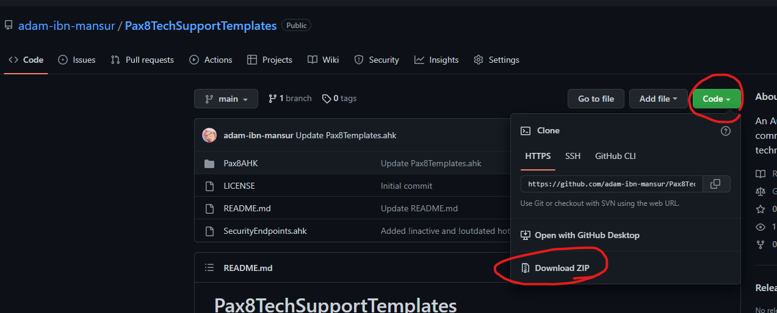

Next, unpack that ZIP folder wherever you want. Then right-click the SecurityEndpoints.ahk file and open it with AutoHotkey.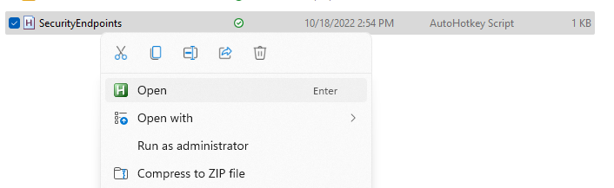

After that, you should be good to go. Check the GitHub’s README for the list of hotstrings/commands (updates will occur in the event a new task befalls the department, but otherwise the bread-and-butter commands will still be there.)

If you would like to contribute to the project in any way, let me know! I can add you as a contributor to the repo. The nice part about AHK is that you can edit the source code in Notepad or a text editor of your choosing – even an IDE like Atom or Visual Studio.

